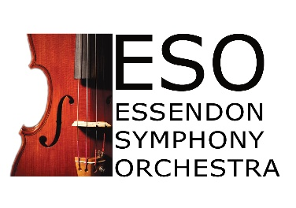
Apply for membership

Name:

Instrument:

Email:

Phone number:

Postal address:

Reasons for wanting to join ESO:

Musical experience:

Once you have completed the form, please email to newplayers@essendonsymphony.com and the membership officer will get back to you.

